|  |  |
| --- | --- |
|  | NAI-ZM Website Development Documentation |
|  |  |
|  | Chibuye  Web Developer  2/5/25 |

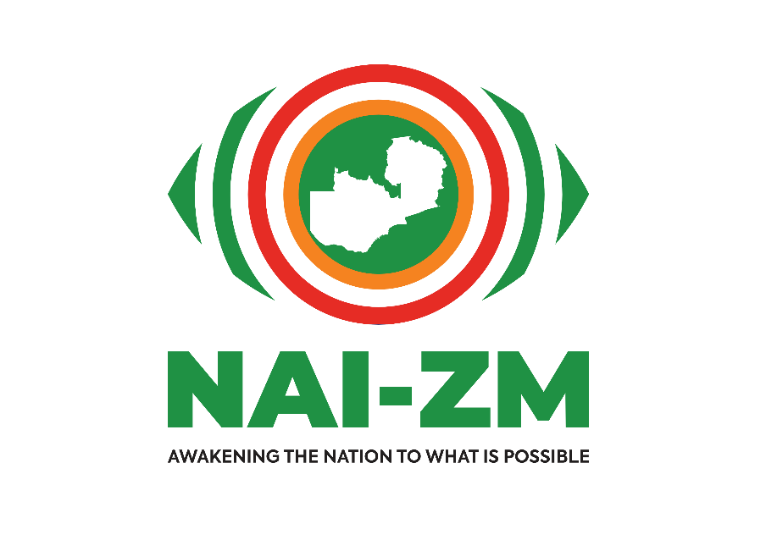

TABLE OF CONTENTS

1. Project Overview
2. Objectives
3. Website Scope
4. Technology Stack
5. Development Approach
6. Implementation Plan
7. Testing Strategy
8. Deployment Plan
9. Future Enhancements
10. **PROJECT OVERVIEW**

• **Project Name:** NAI-ZM Website

• **Purpose:** Build an online platform for advocacy, activism, and voter education.

• **Target Audience:** Zambian citizens, activists, policymakers.

• **Primary Goals:**

* Educate the public on governance & constitutional reform
* Increase civic engagement
* Provide information on events & campaigns
* Allow volunteers & donors to contribute

1. **OBJECTIVES**  
   the main objective of this project is to build an accessible, user-friendly website for NAI-ZM that supports civic engagement, activism, voter education, and facilitates volunteerism and donations.

The specific objectives of this project are:  
i. To build an accessible and easy-to-navigate website that enhances user experience for all visitors.  
ii. To ensure the website design is mobile-friendly and responsive, offering seamless access across various devices.  
iii. To implement secure user interaction features, such as contact forms and membership registration, ensuring privacy and data protection.  
iv. To provide real-time updates on campaigns, events, and activities, keeping visitors informed and engaged.

1. **WEBSITE SCOPE**

**✅ Pages & Features**

1. **Home Page**
   * Overview of the organization's mission and vision.
   * Display of latest updates or important announcements (e.g., current campaigns).
   * Eye-catching call-to-action buttons (e.g., "Get Involved," "Donate").
2. **About Us**
   * Brief history of the organization and its founding.
   * Introduction of the team members with their roles and expertise.
   * Clear articulation of the organization's objectives, vision, and goals.
3. **Get Involved**
   * Volunteer sign-up form with options to choose roles or areas of interest.
   * Links to donation pages (e.g., PayPal, bank details, crowdfunding platform).
   * Highlight opportunities for partnerships and collaborations.
4. **Events & Campaigns**
   * Upcoming events with date, time, and location.
   * Information on past events, including photos and key takeaways.
   * A calendar or timeline feature to track future campaigns.
5. **Blog/News**
   * Articles focusing on activism, governance, and other relevant topics.
   * A news section to update visitors on the organization’s progress or major achievements.
   * Option for users to comment and engage with the content.
6. **Contact Us**
   * Inquiry form to allow visitors to reach out with questions or comments.
   * Contact information including email addresses and phone numbers.
   * Links to social media platforms for further engagement (e.g., Facebook, Twitter, and Instagram).
7. **TECHNOLOGY STACK**

✅ **Frontend:**

* HTML
* CSS
* JavaScript (Vanilla)

✅ **Backend (if needed):**

* PHP (Laravel)

✅ **Database (if needed):**

* MySQL

✅ **Hosting(Temporarily):**

* GitHub Pages
* Netlify

1. **DEVELOPMENT APROACH**

**Lifecycle Model:** Agile – Iterative development with continuous improvements. This approach will allow flexibility and adaptability throughout the development process, ensuring that we can address any changes or new features as they arise.

**Version Control:** GitHub repository for tracking changes, version history, and collaboration.

**Development Phases:**

🔹 **Phase 1:** Static pages (Home, About, Contact)

* Focus on building the foundational pages of the website with basic information.

🔹 **Phase 2:** Blog & Events section

* Add a dynamic section for news, articles, and event updates.

🔹 **Phase 3:** Membership & Donations system

* Introduce user interaction features like membership registration and donation links (can be kept simple for now).

🔹 **Phase 4:** SEO & security enhancements

* Improve search engine visibility and implement basic security measures to safeguard user interactions.

1. **IMPLEMENTATION PLAN**

**Overview:**The Implementation Plan outlines the key steps, resources, and timeline to guide the successful development and launch of the NAI-ZM website. The website will be built using an agile approach to ensure flexibility and continuous improvement.

**Development Phases:**

* **Phase 1: Static Pages (Home, About, Contact)**
  + **Objective:** Develop the basic structure of the website, including static content such as the homepage, about page, and contact form.
  + **Duration: 2 weeks**
  + **Key Activities:**
    - Design and develop the homepage with key information about the mission and vision.
    - Create the About Us page with information on the organization and its team.
    - Implement a simple Contact Us form for user inquiries.
    - Test the responsiveness and accessibility of these pages.
  + **Deliverables**: Basic pages for home, about, and contact.
* **Phase 2: Blog & Events Section**
  + **Objective:** Add dynamic content capabilities, including blog posts and events.
  + **Duration:** 2 weeks
  + **Key Activities:**
    - Create templates for blog posts, ensuring easy-to-read formats.
    - Build an events section with upcoming and past events.
    - Implement the ability for users to comment and engage with blog posts.
    - Test integration with the backend, if necessary**.**
  + **Deliverables:** A functional blog and events section.
* **Phase 3: Membership & Donations System**
  + **Objective:** Implement user interaction features for membership registration and donations.
  + **Duration**: 3 weeks
  + **Key Activities:**
    - Set up membership registration forms.
    - Add donation options with integration to payment systems (e.g., PayPal).
    - Ensure security and data privacy for user interactions.
    - Test forms and donation system.
  + Deliverables: Working membership system and donation page.
* **Phase 4: SEO Optimization & Security Enhancements**
  + **Objective:** Enhance search engine visibility and ensure secure user interaction**.**
  + **Duration:** 2 weeks
  + **Key Activities:**
    - Optimize the website’s content for SEO (keywords, meta descriptions).
    - Implement basic security measures, such as HTTPS, form validation, and protection from attacks.
    - Perform load testing to ensure scalability.
  + **Deliverables:** SEO-optimized website and security enhancements.

1. **TESTING STRATEGY**

* Unit Testing – Test individual components (e.g., form validation).
* Integration Testing – Ensure frontend-backend communication works.
* User Testing – Ask NAI-ZM members to test features.

1. **TIMELINE**

* **Weeks 1-2 (February 2025):** Phase 1 - Static Pages
* **Weeks 3-4 (March 2025):** Phase 2 - Blog & Events Section
* **Weeks 5-7 (March-April 2025):** Phase 3 - Membership & Donations System
* **Weeks 8-9 (April 2025):** Phase 4 - SEO & Security Enhancements
* **Week 10 (May 2025):** Final testing and launch preparations

1. **Budget**

For this project, the primary expense will be the data costs associated with the development and maintenance of the website. The budget will be focused on the data required for development, testing, and deployment.

**Data Costs:**

* **Development Data Usage:** Costs for internet access and data usage while building the website, including researching, coding, and testing.
  + Estimated monthly data usage: **K200/month**